Table of Contents

1. INTRODUCTION 3

2. METHODOLOGY 3

2.1. Experiment Procedure and Data Acquisition 3

2.2. Data Loading and Preprocessing 3

2.3. Statistical Noise Assessment 3

2.4. Digital Filter Design 4

3. ERROR ASSESSMENT 5

4. DIGITAL FILTER DESIGN 6

5. ETHICAL IMPLICATION 8

6. CONCLUSION 8

REFERENCES 8

APPENDIX A 9

List of Figures and Tables

Figure 1. DC motor with imbalanced mass rotor (left) and charged amplifier (right) 3

Figure 2. ANOVA Table 5

Figure 3. ANOVA Box Plot 5

Figure 4. Motor Acceleration Raw Signals at 1V, 2V, and 3V 6

Figure 5. Raw and Filtered Signals of Motor Acceleration 7

Figure 6. Raw Signal Single-sided Frequency Spectrum 9

Figure 7. Filtered Signal Single-sided Frequency Spectrum 9

Table 1. Mean, Standard Deviation and SNR of Raw Signals 6

Table 2. Mean, Standard Deviation and SNR of Filtered Signals at various Cut-off Frequencies 7

# INTRODUCTION

In this assignment, we aim to analyse the acceleration data from a DC motor at various speeds and design a digital filter to minimise the noise. The motor’s acceleration data is captured at three different speeds: 1V, 2V, and 3V. The data is first assessed for noise characteristics by applying statistical methods, including mean, standard deviation, signal-to-noise ratio (SNR), and ANOVA. Subsequently, an appropriate digital filter is designed and applied to the data to enhance signal quality. The effectiveness of the filtering process is evaluated through statistical analysis by comparing the SNR before and after filtering. Additionally, the report addresses ethical considerations related to the experiment and provide a detailed methodology for replicating the study.

1. METHODOLOGY
   1. Experiment Procedure and Data Acquisition

In this experiment, we used a Maxon DC motor with an imbalance mass rotor, motor drive and encoder, connected to a charged accelerometer and charged amplifier (figure 1). The signal is digitized and acquired by the USB-6351 DAQ Board and sampled at a frequency of 10 kHz, which outputs the acceleration, speed, and current signals through the LABVIEW program and generates raw data files. For the analysis, we focused on the acceleration component of the DC motor when the motor speed is set to 1V, 2V, and 3V. At each voltage level, the data is recorded for 1 second. The acceleration is measured by the vibration at the bottom of the motor, which outputs an oscillated digital signal.

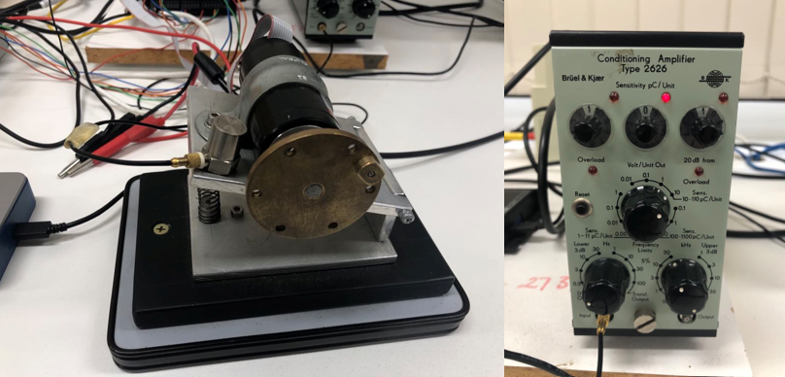

Figure 1. DC motor with imbalanced mass rotor (left) and charged amplifier (right)

* 1. Data Loading and Preprocessing

The initial step after data acquisition involves loading the acceleration data captured from a DC motor. The raw data is obtained from a ‘.lvm’ file, which contains time and acceleration measurements at various speeds. The data file is loaded into MATLAB for plotting the acceleration [V] with respect to time [s].

* 1. Statistical Noise Assessment

Mean and standard deviation are necessary components to evaluate the noise in the signal. The mean represents the central value of the signal. It is calculated using the following equation:

$$μ=\frac{1}{N} \sum_{i=0}^{N-1}{x_{i}}$$

where N is the number of samples, and x is the signal value at index each index i.

Along with mean, standard deviation further quantifies the noise level by measuring how far the signal fluctuates from the mean. It is calculated by the following formula:

$$σ^{2}=\frac{1}{N-1}\sum_{i=0}^{N-1}{{\left(x_{i}-μ\right)}^{2}}$$

With mean and standard deviation, the signal-to-noise ratio (SNR) can be acquired by taking the division between mean and standard deviation (Smith 1997).

$$SNR=\frac{μ}{σ}$$

The error assessment involves evaluating the noise characteristics in the acceleration data recorded at different motor speeds (1V, 2V, 3V). From the collected data, the noise is estimated by subtracting the mean value of the signal. This helps isolate the random variations in the data, which is considered as noise. To determine if there are statistically significant differences in the noise levels across the various speed settings, we apply the analysis of variance (ANOVA) test (Assaad, Zhou et al. 2014).

ANOVA works by partitioning the total variability of the data into variability between groups and within groups. The F-statistic is calculated to determine if the between-group variability is significantly greater than the within-group. A p-value will be obtained to test the null hypothesis, where all group means are equal. If the p-value from the ANOVA test is less than a chosen significance level, such as 0.05, we reject the null hypothesis, indicating that at least one group mean is different. This informs us if different filtering strategies are necessary for each speed setting.

* 1. Digital Filter Design

A digital filter will be designed to remove high-frequency noise from the acceleration signals. A Butterworth low-pass filter is chosen for its flat frequency response in the passband, ensuring minimal signal distortion while effectively attenuating high-frequency noise. The filter parameters, including the cut-off frequency and the filter order, are determined based on the noise characteristics observed in the data. The Butterworth filter is widely recognised for its smooth frequency response, making it suitable for various applications, including biomedical signal processing (Kumngern, Aupithak et al. 2020) and motor control systems. For instance, Psychalinos and Elwakil (2023) demonstrated the advantages of Butterworth filters in terms of controllable cut-off frequencies and reconfigurable designs, highlighting their effectiveness in different contexts.

Finally, to evaluate the effectiveness of the low-pass filter, SNR values of the original and filtered signals will be compared. An increase in SNR after filtering indicates successful noise reduction.

1. ERROR ASSESSMENT

To evaluate the noise levels in the acceleration data at various motor speeds, a one-way ANOVA was performed in MATLAB, assuming the noise is the deviation of the acceleration data from its mean value. The goal was to determine whether there were statistically significant differences in the noise characteristics across these three conditions.

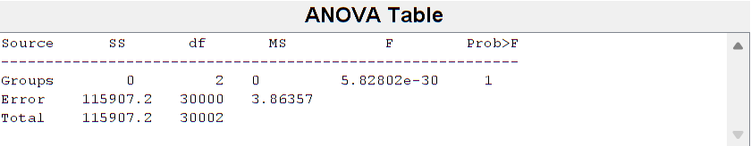

Figure 2. ANOVA Table

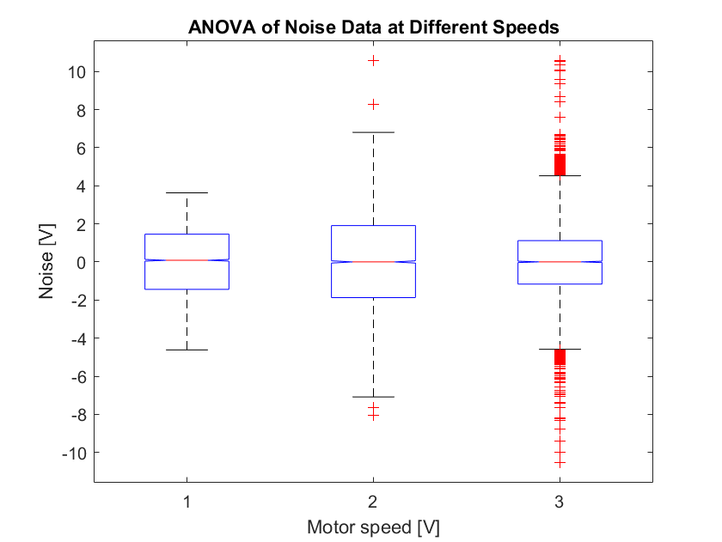

Figure 3. ANOVA Box Plot

The ANOVA table and box plot are shown in figure 2 and 3, respectively. The box plot displays the distribution of noise data for each speed. When the speed is set at 1V, the noise data shows a relatively tight distribution with a median around 0 and range of 4 (from -2 to 2). At 2V, the noise data has a wider distribution compared to the former, with a similar median of 0 and ranges from -5 to 5. There are several outliers indicating more variability. At the speed of 3V, the noise data distribution is similar to 1V but with more outliers, showing slightly more variability.

The ANOVA analysis resulted in a F-statistic of 5.28e-30 with a p-value of 1. This indicates that there is no significant difference between the noise levels at three different speeds. The p-value greater than 0.05 suggests that any observed differences in the noise levels are likely due to random variation rather than a true underlying difference between the groups.

Overall, the results of the ANOVA analysis indicate that the noise levels are statistically similar across the different motor speeds. Therefore, the same filtering strategy can be applied uniformly across all scenarios. This finding simplifies the filter design process, as a single filter configuration can be expected to perform consistently for the acceleration data at 1V, 2V, and 3V. The next steps involve designing and applying a Butterworth low-pass filter to the acceleration data, assessing its performance in reducing noise and improving the signal-to-noise ratio.

1. DIGITAL FILTER DESIGN

The raw signals from the three datasets are plotted in figure 4, capturing motor acceleration at motor speeds of 1V, 2V, and 3V, respectively. From these plots, it is evident that the majority of the noise components are high frequency, indicating that a low-pass filter is appropriate for filtering the raw signals.

Figure 4. Motor Acceleration Raw Signals at 1V, 2V, and 3V

To quantify the noise level, we first examine the mean and standard deviation of the raw data, which are then used to calculate the signal-to-noise ratio (SNR). Table 1 lists these parameters for each motor speed. The low SNR values indicate a significant presence of noise in the original signals to be filtered.

Table 1. Mean, Standard Deviation and SNR of Raw Signals

|  |  |  |  |
| --- | --- | --- | --- |
| Motor speed | Mean | Standard deviation | SNR |
| 1V | 0.010 | 1.495 | 0.007 |
| 2V | 0.015 | 2.164 | 0.007 |
| 3V | 0.027 | 2.162 | 0.011 |

In MATLAB, a 4th order Butterworth filter was designed to eliminates the high frequency components while retaining important lower frequency components. The sampling frequency of the filter chosen 10 kHz, which is the same as the sampling rate when collecting the data. Since there are a lot of high frequency noises, the cut-off frequency is selected between 100 Hz and 500 Hz.

A 4th order Butterworth filter was designed in MATLAB to remove high-frequency components while preserving important low-frequency components. The filter’s sampling frequency is 10kHz, matching the data acquisition sampling rate. Considering the high level of high-frequency noise, the cut-off frequencies were chosen between 100 Hz and 500 Hz.

Table 2. Mean, Standard Deviation and SNR of Filtered Signals at various Cut-off Frequencies

|  |  |  |  |  |
| --- | --- | --- | --- | --- |
| Cut-off frequency | Motor speed | Mean | Standard deviation | SNR |
| 500 hz | 1V | 0.011 | 0.058 | 0.182 |
| 2V | 0.013 | 0.185 | 0.072 |
| 3V | 0.025 | 0.349 | 0.072 |
| 200 hz | 1V | 0.010 | 0.040 | 0.249 |
| 2V | 0.013 | 0.133 | 0.096 |
| 3V | 0.026 | 0.224 | 0.116 |
| 100 hz | 1V | 0.009 | 0.034 | 0.277 |
| 2V | 0.010 | 0.151 | 0.068 |
| 3V | 0.027 | 0.175 | 0.153 |

After applying the low-pass filter to the digital signals, the SNR values were recalculated to evaluate the effectiveness of the filter. Table 2 shows that filtering at a cut-off frequency of 100 Hz significantly improves the SNR values in comparison to the original signals. Figure 5 illustrates the comparison between the raw and filtered signals. Additionally, the single-sided frequency spectrum analysis reveals differences in frequency component at various motor speeds, unlike the original signals which exhibit consistent frequencies across different speeds.

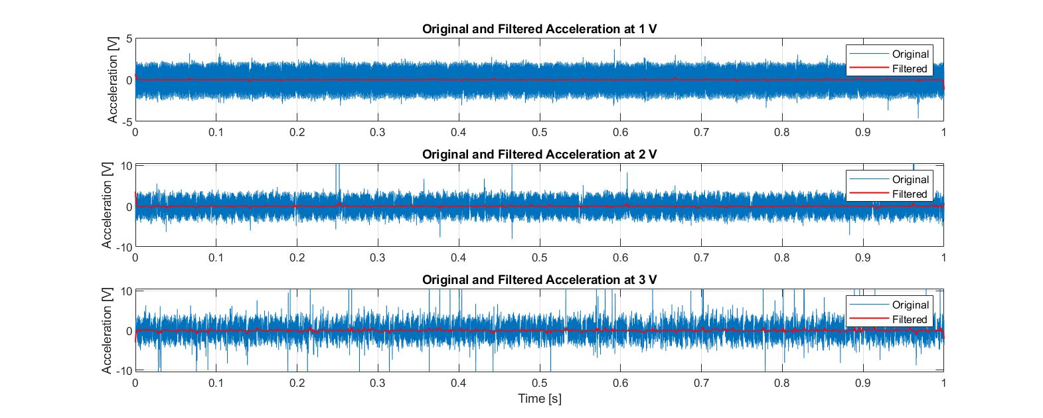

Figure 5. Raw and Filtered Signals of Motor Acceleration

Overall, the application of a 4th order Butterworth low-pass filter reduced high frequency noise in the motor acceleration signals, as evidenced by improved SNR values. A cut-off frequency of 100 Hz provides the best results, enhancing the quality of the signals. The frequency spectrum analysis further highlights the differences in frequency content at various motor speeds, demonstrating the filter’s effectiveness in improving the signals’ quality.

1. ETHICAL IMPLICATION

For this experiment, the data is collected using a DC motor and Data Acquisition (DAQ) Board in a controlled laboratory environment, ensuring minimal external interference. The only human involvement was by the experiment conductor. Additionally, the recorded acceleration data does not involve any personal identifiers, such as GPS signals or body movement tracking, ensuring that there are no privacy concerns (McMenemy 2021). Consequently, there is no ethical implications associated with this report.

1. CONCLUSION

In this paper, we have analysed the acceleration data from a DC motor operating at different speeds and designed an effective digital filter to minimise noise. The initial statistical analysis revealed significantly high frequency noise in the raw acceleration signals. Through the application of ANOVA, we determined that the noise levels were statistically similar across the various motor speeds, allowing us to apply a uniform filtering strategy. A 4th order Butterworth low-pass filter was implemented, with a cut-off frequency optimised between 100 Hz and 500 Hz. The filtered signals exhibited improved signal-to-noise ratio (SNR), with a cut-off frequency of 100 Hz yielding the best results. The Butterworth filter’s smooth frequency response ensured minimal signal distortion while attenuating high frequency noise.

Overall, the findings demonstrate that a more well-designed Butterworth low-pass filter can be developed to further enhance the quality of motor acceleration signals by reducing high-frequency noise. This methodology can be applied in various practical applications where noise reduction is crucial for accurate signal analysis.

# REFERENCES

Assaad, H. I., et al. (2014). "Rapid publication-ready MS-Word tables for one-way ANOVA." SpringerPlus 3(1): 474.

Kumngern, M., et al. (2020) 0.5 V Fifth-Order Butterworth Low-Pass Filter Using Multiple-Input OTA for ECG Applications. Sensors 20, DOI: 10.3390/s20247343.

McMenemy, D., 2021. Ethical Issues of Digital Signal Processing. In *Intelligent Computing for Interactive System Design: Statistics, Digital Signal Processing, and Machine Learning in Practice* (pp. 141-142).

Nako, J., Psychalinos, C. and Elwakil, A. S. (2023) 'A 1 + α Order Generalized Butterworth Filter Structure and Its Field Programmable Analog Array Implementation', Electronics, 12(5). DOI: 10.3390/electronics12051225.

Smith, S.W., 1997. The scientist and engineer's guide to digital signal processing (pp. 13-17).

# APPENDIX A

Figure 6. Raw Signal Single-sided Frequency Spectrum

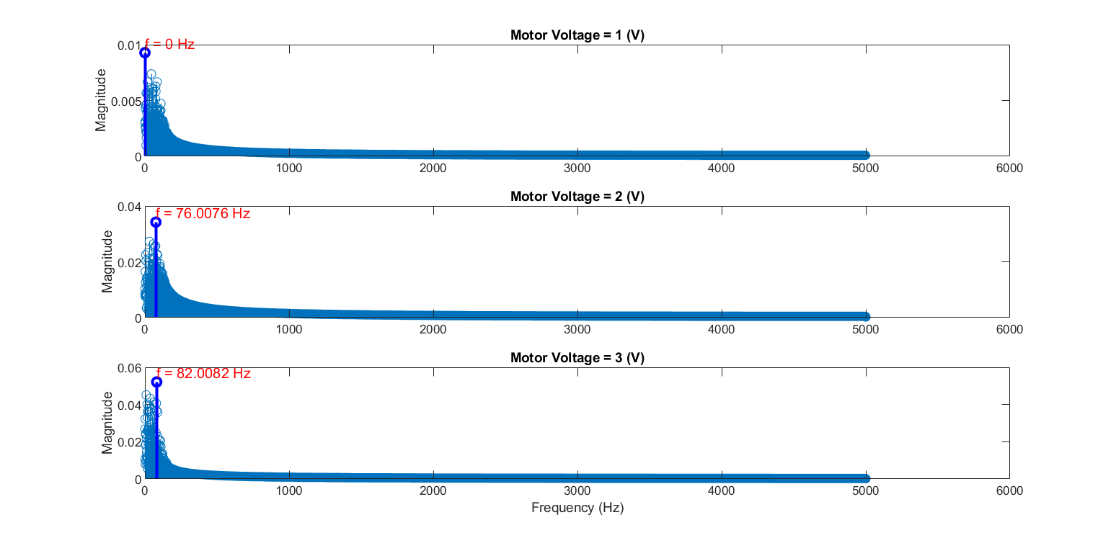

Figure 7. Filtered Signal Single-sided Frequency Spectrum